**DESIGNING A RESUME/CV USING CANVA**

Project report template:

**INTRODUCTION**

**1. 1 Over view:**

Resume design is the structure, look and format of a resume. A professionally desighing resume can improve your resume's appeal and support its content. It can make it easier to read and highlight essential information. An effective resume features professional and easy-to-read fonts (as opposed to fancy typography), single-line spacing, clear section headings, and half-inch margins. The first page or top half of your resume should include your contact information and personal summary.

**1. 2 purpose**

The purpose of a resume is to introduce yourself to employers, present your qualifications, and secure an interview. Writing a resume aims to showcase your experience, education, and skills in a standardized format that is easy for recruiters to read.

* [Contact information](https://zety.com/blog/resume-contact-information): your name, phone number, email address, and optionally relevant social media handles, such as your LinkedIn profile. In most cases, leave your [address off your resume](https://zety.com/blog/address-on-resume).
* [Resume profile](https://zety.com/blog/resume-profile): a summary of your skills and proudest accomplishments. It tops your resume and serves as your job bio.
* [Work experience section](https://zety.com/blog/work-experience-resume): only your [relevant work experience](https://zety.com/blog/relevant-experience). It’s where you tell your career history. This section includes your [job titles](https://zety.com/blog/job-titles), company names, duties, and years worked.
* [Education section](https://zety.com/blog/education-on-resume): your school names, [academic degrees](https://zety.com/blog/how-to-list-degree-on-resume), [major and minors](https://zety.com/blog/how-to-list-minor-on-resume), and optionally your [high GPA](https://zety.com/blog/gpa-on-resume) plus [relevant coursework](https://zety.com/blog/relevant-coursework-resume).
* [Skills section](https://zety.com/blog/what-skills-to-put-on-a-resume): job-related skills that may be of value to your prospective employer. Well-crafted key skills sections can boost your chances of getting a job. Always include [soft skills](https://zety.com/blog/soft-skills) and [hard skills](https://zety.com/blog/hard-skills), and keep in mind that, according to a study, [76% of recruiters](https://resumelab.com/resume/how-to) prefer the two types of skills separated from one another.

**2. PROBLEM DEFINITION & DESIGNING THINKING:**

**2. 1 Empathy Map:**

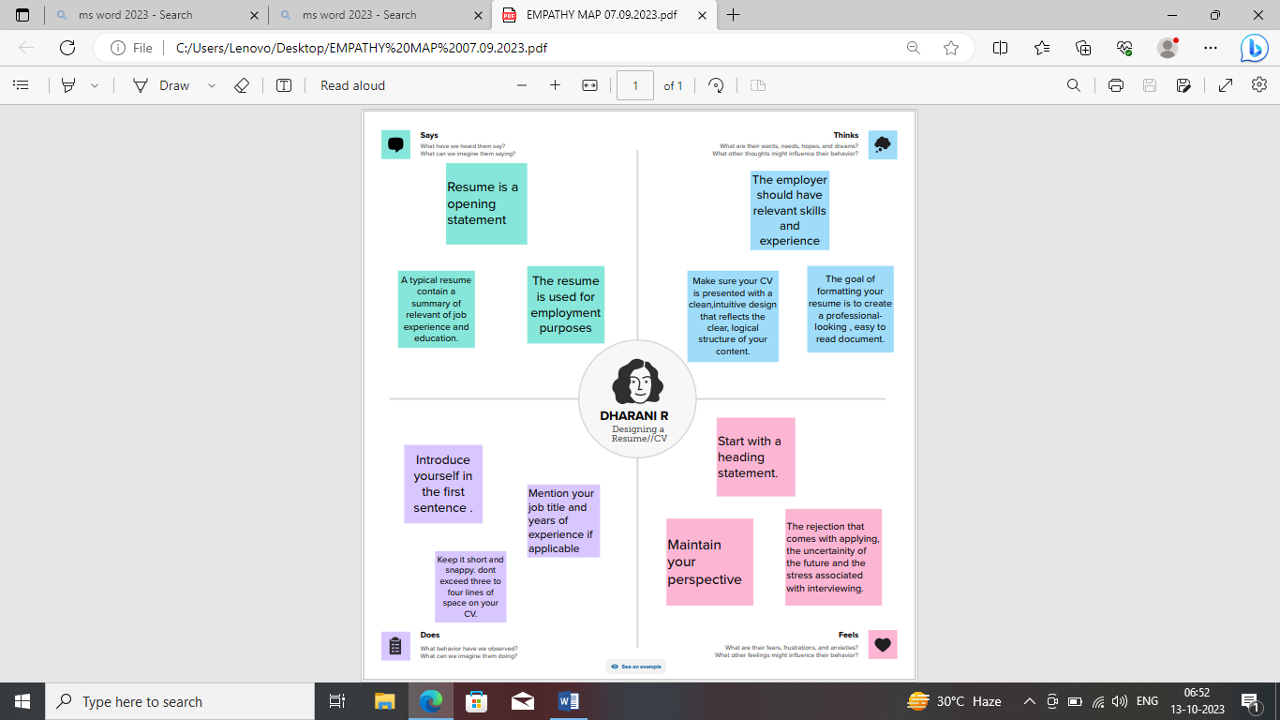

**2. 2 Ideation & Brainstorming :**

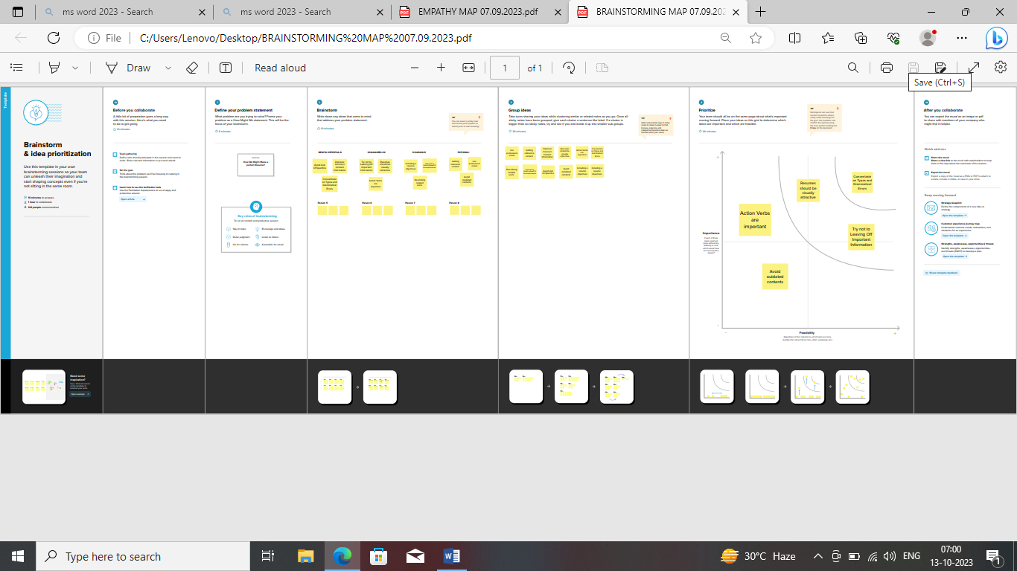

**3. RESULT:**

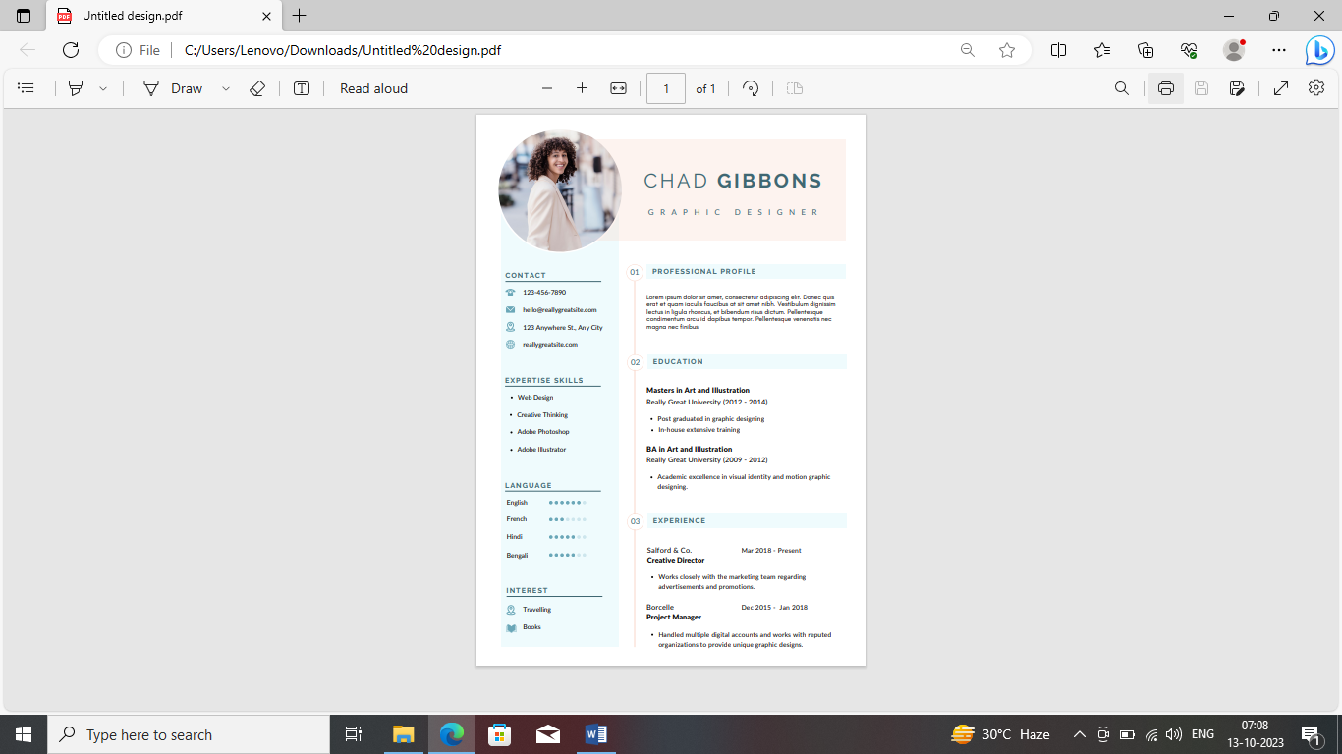

**4. ADVANTAGES AND DISADVANTAGES :**

1. makes it more likely that you will be hired: Your abilities, experiences, and accomplishments can be highlighted in a well-written resume, which can attract the attention of potential employers and improve your chances of getting hired.

2. Reduces time: Employers will spend less time and effort sorting through multiple resumes if a resume is clear and concise. As a result, they may be more likely to consider you for an interview and spend more time reviewing your application.

3. demonstrates your expertise and skills: An effective resume highlights your abilities, experiences, and accomplishments in a clear and concise manner, demonstrating your value. It is an opportunity to visually present your qualifications and make a positive first impression.

4. makes you distinctive: A good resume should be written specifically for you. A resume that is focused and tailored to you can help you stand out from other applicants and make yourself easier to remember and distinguish.

5. Boosts your self-assurance: An effective resume highlights your skills, experience, and accomplishments. This can boost your self-assurance when applying for a job, which can have an effect on how well you do in the interview

**6.Provides Better Continuity for Your Story**:A longer resume allows you to craft better content for each key section. You will have more opportunity to weave your story into the resume and create continuity. You can lead the hiring manager further along your story as he or she goes through your resume.If you were successful in launching your story at the Header, it will be easy for the hiring manager to establish continuity simply by noting keywords at each section. Continuity of a compelling storyline could potentially distinguish you from the rest of the competition.

**7.Risk of overlooking the important facts**:The chances are that the employer will miss reading the most important information if you stuff too much information in the [resume](https://iibmindia.in/apply-and-pay-online/resume-writing-is-the-resume-length-even-important/). The reader will most likely doze off while reading your resume. So, stick to a professional resume format that helps scatter the right information in the right places in your job resume.

**5.APPLICATION :**

Resume design is the structure, look and format of a resume. A professionally desighing resume can improve your resume's appeal and support its content. It can make it easier to read and highlight essential information**.**

**6.CONCLUTION :**

Through this project we learnt to create any types of resume with canva.This project is useful to us to give a good performance in interviews.